

# NetCrew Shopping Site (Deliverable 1)

## Portal Flow Document Image:

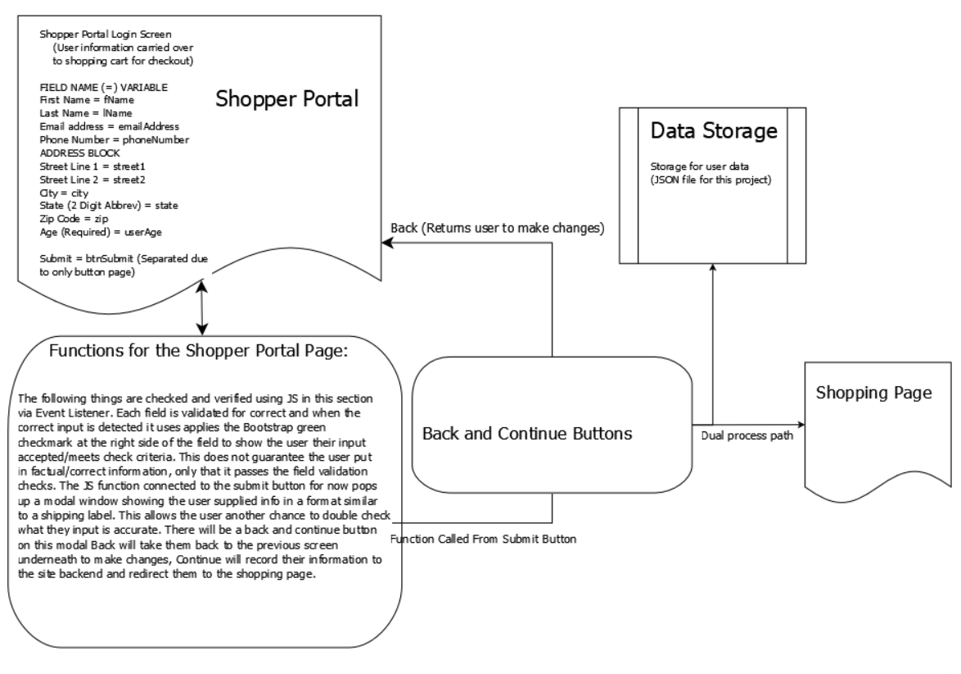

Figure 1 Flow Diagram

### Description:

The above Screenshot gives an overview of the general flow of the initial document prototype. It shows how the input from the user is handled and where the user will end up when they correctly input the correct information to continue shopping. The block labeled Shopping Page is the next step in the site progress and will be represented in a different future diagram.

We will be incorporating multiple technologies in bringing this shopping site together, they are listed here along with the respective team members responsible for contributing to that area. It should also be noted that there is overlap in the process and method so any one team member could make some contribution in multiple areas.

### Tech, and Team Member:

|  |  |
| --- | --- |
| Technology | Team Member |
| HTML | James Do,  Alajah Rivera |
| CSS | James Do,  Alajah Rivera |
| BootStrap | Grace Kang |
| JavaScript | Rob Geist (Front and Back End) |
| JSON and other Database tech. | Jamal Barker |

Project Layout:

Figure 2 Project Block Diagram

## A screenshot of a computer Description automatically generatedInitial Page Prototype Screen Shots:

Figure 3 Shopper page with modal window

Figure 2 Shopper page

### Description:

Sample Prototype Screenshot for initial page. Information was entered to show user input is in effect. Each of the fields will contain validation to ensure accuracy of the user input. There is also a hover element added to the submit button, so mouse users know when they are over the button. When the form is submitted it will present the user with a modal showing their entered information in a shipping label format to review for accuracy. There are two buttons on the modal: [Close], and [Shop]. If user info is correct, then click shop to continue on to the shopping page. If changes need made, then click close and edit the info and submit again.

## Custom Site-Specific CSS Sample:

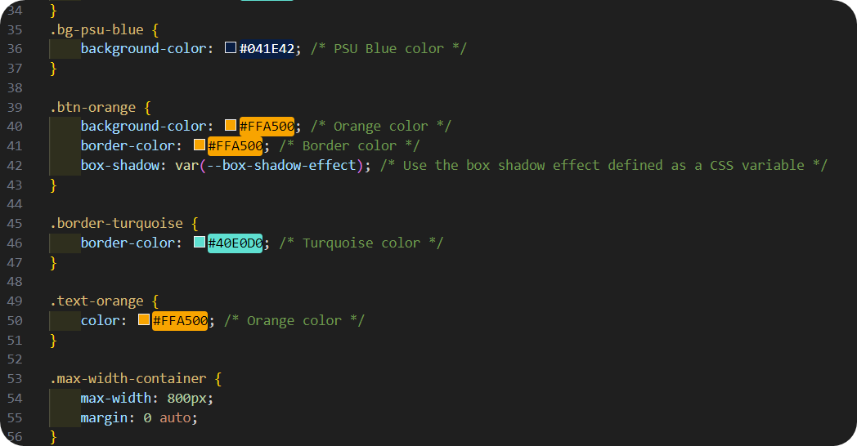

Figure 4 CSS Sample Screen Shot

### Description:

The CSS code provided displays the detail-oriented features for the webpage above. Within this code, the background color commented “PSU Blue” is displayed along the store’s webpage. The background color commented “Orange color” is used to fill in the radio button labeled “Submit”. The text color is also orange to display “Shopper Management”. We added shadow effects along the border of the page to create dimension.

## Custom Site-Specific HTML Sample:

Figure 5 HTML Sample Screen Shot

### Description:

The HTML code below provides the foundation of our storefront webpage. The header was created to display “Shopper Management” and below, labels were created. This includes all of the labels needed for user input. We are asking the user to input “First Name, Last Name, Email Address, Street, City, State, and Zip code”. This will ensure a proper mailing label, when items need to get shipped out to the customer. Within the class, we added a character/string checker to ensure that the information being inputted by the user is accurate and that the code will except the data. If the data meets our codes requirements a green check mark icon will appear.

## Custom Site-Specific JavaScript Sample Screen Shot:

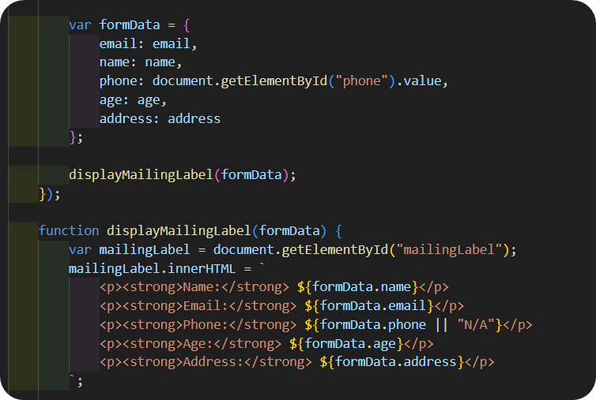

Figure 6 JavaScript Sample Screen Shot

### 

### Description:

The purpose of this JavaScript code is to facilitate the collection and presentation of user-provided data, likely from a web form. It constructs an object named ‘formData’ to organize information such as email, name, phone number, age, and address. Additionally, the ‘displayMailingLabel’ function is designed to visually present this collected data, typically in a mailing label format on a web page. The function dynamically updates the content of an HTML element identified by the ‘mailingLabel’ id to display the gathered information in a structured manner. This code serves to streamline the process of capturing user input and presenting it in a user-friendly format for various applications, such as generating mailing labels or displaying user profiles.